**ADT Lab 4 (10pts)**

**Q1**

**Q2**

**Q3**

**Q4**

**Highlight the questions you are done with to green colour before you submit**

Setup Instructions-

1. Download the files ADT Lab 4.docx, create_table.sql, insert_table.sql files from canvas.
2. Create a new database with your IU username (or use the one that you might have created in previous labs)
3. Run the sql commands in create_table.sql to create new tables.
4. Run the sql commands in insert_table.sql to populate all the tables.

Questions

1. Observe the create queries in the file create_table.sql. There are foreign key constraints on several tables.

Run the quey- SELECT * FROM countries WHERE region_id=3;

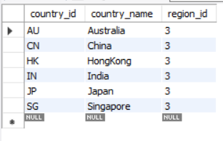

See that we have several records with region_id 3. The column region_id in countries table is a foreign key which references the column region_id in regions table.

SELECT * FROM REGIONS;

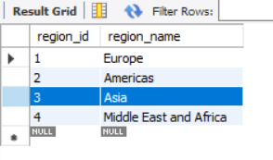

In country table region_id corresponds to the region_name Asia.

Let’s try to delete the region_id 3 from table country.

Run the query-

DELETE FROM regions WHERE region_id=3;

After successfully executing this query, check the countries table again-

SELECT * FROM countries where region_id=3;

It should show an empty result

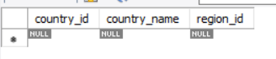

Why did this happen? Even though we deleted the records from regions table all the records in the country table with region_id=3 vanished.

Write an explanation below with the reason.

# Write your answer below.

Since we are using this query : FOREIGN KEY (region_id) REFERENCES regions (region_id) ON DELETE CASCADE ON UPDATE CASCADE.  
  
This query says that in table country we have region_id as a Foreign Key which is referencing region_id from regions to region_id in countries. Also, we are using CASCADE delete and update. Hence, if we delete any tuple from regions it will automatically delete the same tuple from countries.

Hint-

<https://dba.stackexchange.com/questions/74627/difference-between-on-delete-cascade-on-update-cascade-in-mysql> (1st answer)

Research more on Cascade if you need more clarity

1. Now let us drop and create a new foreign key constraint
2. Note the name of the foreign key constraint under the Foreign Keys list

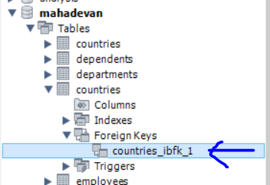

Run the query-

ALTER TABLE countries DROP FOREIGN KEY countries_ibfk_1;

SELECT * FROM countries where region_id=4;

We see the following entries in the county table for region_id=4

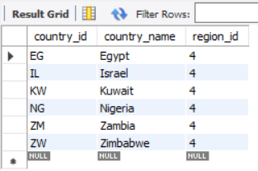

Now let’s delete the region 4 from the regions table using the following query

DELETE FROM regions WHERE region_id=4;

SELECT * FROM REGIONS;

Once deleted we now only have 2 regions in the regions table-

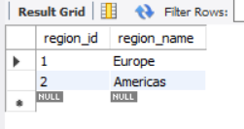

Now let’s check the countries table-

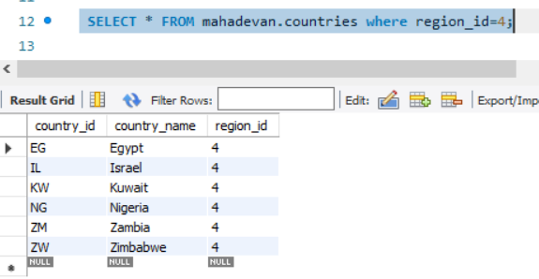

We still have all the entries corresponding to region_id 4 in the countries table even after deleting the region_id 4 in regions table.

Why did this happen?

# Write your answer below.

As previously discussed, CASCADE delete removes not only the target rows from the primary table but also the corresponding referencing rows in other tables. In this particular case, when we altered or dropped the foreign key constraint in the "countries" table, it resulted in the deletion of records from the "regions" table. This explains why records from the "countries" table remained unaffected by the deletion operation.

1. Now let’s try to delete some tables

DROP TABLE jobs;

You won’t be allowed to delete this table because of the foreign key constraint that is being used in the employees table.

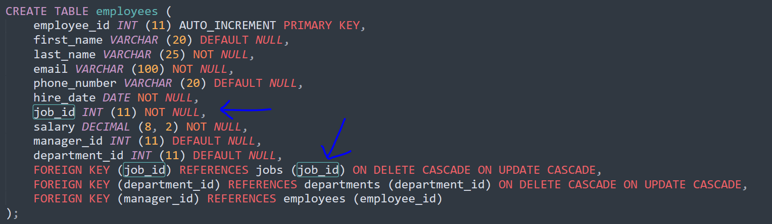

In order to delete the job table, you first need to drop the foreign_key constraint and then delete the table jobs

# Delete the jobs table and post the screenshot below

Hint- First drop the all the foreign key constraint on employee’s table. Then drop the jobs table

ALTER TABLE employees DROP FOREIGN KEY employees_ibfk_1;

#Sample screenshot with no jobs table-

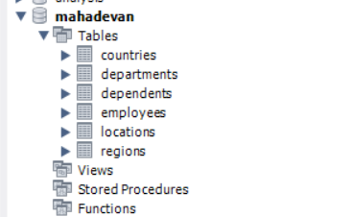

# Your screenshot

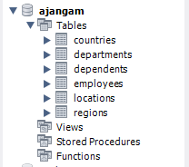

1. Now drop the table regions and countries.

DROP TABLE regions;

If you get an error while deleting the countries table that’s because there is a foreign key in the locations table that’s referencing the column country_id in countries table.

So first drop the foreign key constraint from locations table

ALTER TABLE locations DROP FOREIGN KEY locations_ibfk_1;

Now drop the countries table- Drop table countries;

DROP TABLE countries;

Now recreate the countries and region table with the below queries-

CREATE TABLE regions (

region_id INT (11) AUTO_INCREMENT PRIMARY KEY,

region_name VARCHAR (25) DEFAULT NULL

);

CREATE TABLE countries (

country_id CHAR (2) PRIMARY KEY,

country_name VARCHAR (40) DEFAULT NULL,

region_id INT (11) NOT NULL,

FOREIGN KEY (region_id) REFERENCES regions (region_id) ON DELETE RESTRICT

);

INSERT INTO regions(region_id,region_name) VALUES (1,'Europe');

INSERT INTO regions(region_id,region_name) VALUES (2,'Americas');

INSERT INTO regions(region_id,region_name) VALUES (3,'Asia');

INSERT INTO regions(region_id,region_name) VALUES (4,'Middle East and Africa');

/*Data for the table countries */

INSERT INTO countries(country_id,country_name,region_id) VALUES ('AR','Argentina',2);

INSERT INTO countries(country_id,country_name,region_id) VALUES ('AU','Australia',3);

INSERT INTO countries(country_id,country_name,region_id) VALUES ('BE','Belgium',1);

INSERT INTO countries(country_id,country_name,region_id) VALUES ('BR','Brazil',2);

INSERT INTO countries(country_id,country_name,region_id) VALUES ('CA','Canada',2);

INSERT INTO countries(country_id,country_name,region_id) VALUES ('CH','Switzerland',1);

INSERT INTO countries(country_id,country_name,region_id) VALUES ('CN','China',3);

INSERT INTO countries(country_id,country_name,region_id) VALUES ('DE','Germany',1);

INSERT INTO countries(country_id,country_name,region_id) VALUES ('DK','Denmark',1);

INSERT INTO countries(country_id,country_name,region_id) VALUES ('EG','Egypt',4);

INSERT INTO countries(country_id,country_name,region_id) VALUES ('FR','France',1);

INSERT INTO countries(country_id,country_name,region_id) VALUES ('HK','HongKong',3);

Now we will try to delete from the regions table-

DELETE FROM regions WHERE region_id=1;

It will throw an error.

Why did in throw an error?

# Write your explanation here

We have a foreign key constraint established in the "countries" table that references the "region_id" column in the "regions" table with the ON DELETE RESTRICT option, which caused an issue.

The ON DELETE RESTRICT option means that we cannot delete a record in the "regions" table if there are any corresponding records in the "countries" table that reference it. In this case, since we have inserted records into the "countries" table that reference the "regions" table's region_id, we cannot delete a region in the "regions" table if it is still being referenced in the "countries" table.

Hint- It has something to do with the foreign key constraint that we added when we created the table

But you can safely delete records from the countries table (child table).